ULTRASONIC TESTING REPORT
Company/Client |  | NCOC N. V. |  |  |  | Project |  |  | ESKENE WEST |  |  |  | Location |  |  |  | PGP
Line No/Tag No: |  | A1-4701-FG-003-6-B13-WN |  |  |  | Material |  |  | A333 Gr.6 SMLS |  |  |  | Día × Nominal Thickness |  |  |  | 6 × 7.11 mm
Procedure No: |  | QP-11-UTT-Q01 Rev 03  GOST 28702-90 |  |  |  | Calibration Block |  |  | Step wedge |  |  |  | Probe  S/N |  |  |  | D7908  1214564
 |  |  |  |  |  | Calibration block Range |  |  | 2.5-12.5 mm |  |  |  | Angle |  |  |  | 0º
Manufacturing Code |  | ASME B31.3 |  |  |  | Calibration Temp |  |  | +5ºC |  |  |  | Frequency |  |  |  | 7.5 MHz
 |  |  |  |  |  | Object Temp |  |  | +5ºC |  |  |  | Size |  |  |  | 5.1 mm
Acceptance Standard: |  | Acc. to the client specif. |  |  |  | Correction factors |  |  | n/a |  |  |  | Crystal |  |  |  | Dual
Surface condition |  | Uncoated |  |  |  | Couplant |  |  | UT Gel |  |  |  | Accuracy |  |  |  | ± 0,1 mm
S. No | Equipment/  Material Name |  |  | Manufacturer |  |  | Serial No |  |  |  |  | Calibration certificate No |  |  | Calibration Expiry date
 | 45MG |  |  | OLYMPUS |  |  | 181113402 |  |  |  |  | BK-01-0673 |  |  | 20.03.2020
 | Step calibration block 2214M |  |  | OLYMPUS |  |  | 028719 |  |  |  |  | - |  |  | -
Job description:
- UT measurements were conducted for thickness of pipeline.
- Standard UT technique was used.
Notes:
N/A – not applicable.
DETAILS AND RESULTS
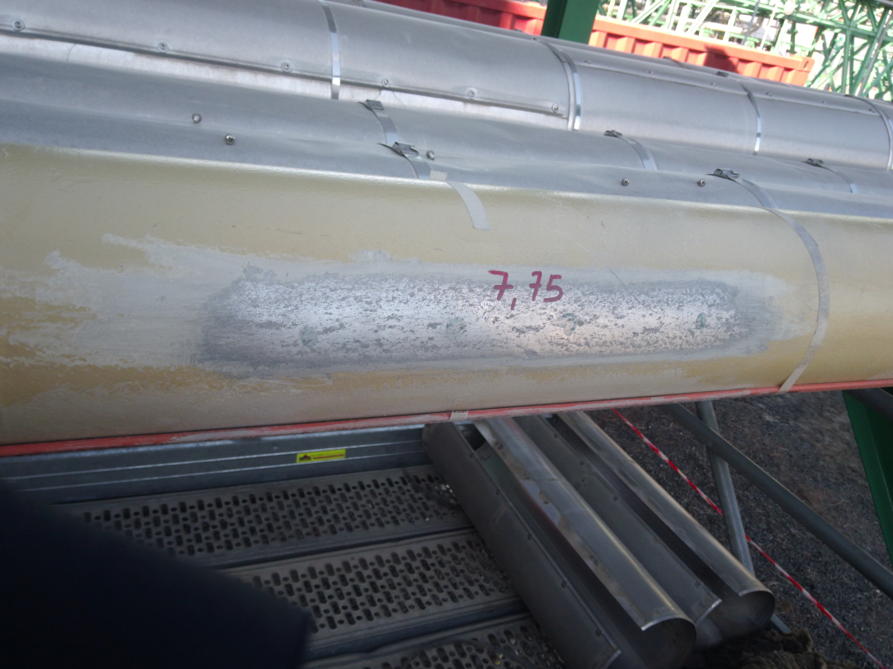
1
2
3
4
Locations |  |  |  | DIA(Ø), inch | Remarks |  |  | Results, mm
 |  |  |  | DIA(Ø), inch |  |  |  | 1 |  |  | 2 |  |  | 3 |  |  |  | 4
UTT spot |  |  |  | 6 | East Side |  |  | 7.80 |  |  | 7.73 |  |  | 7.78 |  |  |  | 7.72
Examined by  UT L II cert. No 1400  exp. date: 31.01.2023 |  |  | Name: Kosmukhambetov Rustembek |  |  |  |  |  |  | Signature: ................................ |  |  |  |  |  | Date: 01 Mar 2019
Approved by UT Level II  cer. No 1A 253/15  exp date: 31.05.2020 |  |  | Name: Shakunou Andrei |  |  |  |  |  |  | Signature: ............................. |  |  |  |  |  | Date: 01 Mar 2019
Client Representative: |  |  | Name: …………………………… |  |  |  |  |  |  | Signature: ................................. |  |  |  |  |  | Date: ………………

